EXPERIMENT – 3
Name: B Mohith
Roll No: 2520030028
Section: 8
Title
Process Creation and Process State Observation using fork()
Aim
To create a child process using fork(), display the PID, PPID, and process state of the parent and child processes, and observe the process state transitions.
Theory
A process is a program in execution.
- fork() creates a new child process.
- getpid() returns the PID of the current process.
- getppid() returns the PID of the parent process.
- wait() allows the parent process to wait for the child process to complete.
- The process state can be observed using the ps command.
- Common process states include running and sleeping.
Algorithm
- Start the program.
- Call fork() to create a child process.
- Check whether fork() was successful.
- If fork() returns 0, execute the child-process code.
- Display the child PID and parent PID.
- Make the child process sleep for a few seconds.
- In the parent process, display the parent PID and child PID.
- Use wait() so the parent waits for the child.
- Observe the process using the ps command.
- Display the completion message and terminate the program.
Program Code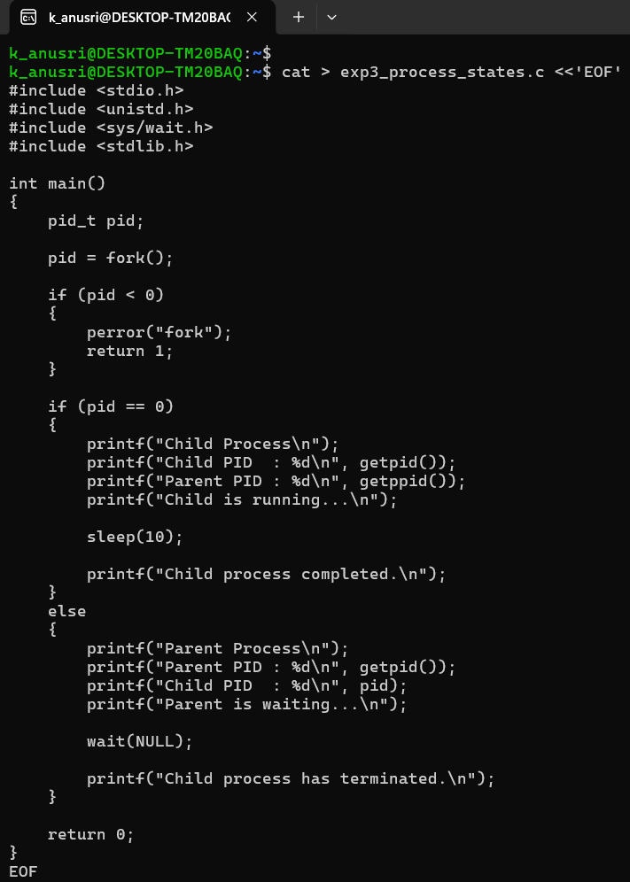
Execution and Screenshots
Screenshot 1 — Compilation and Program Execution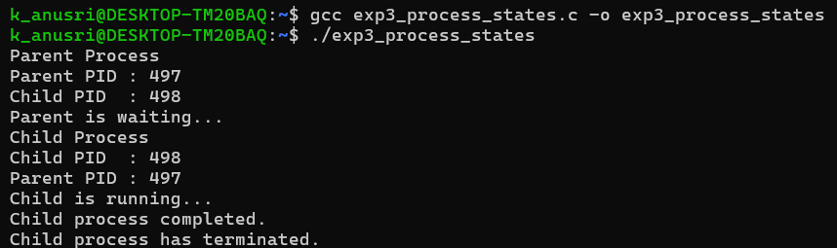
Screenshot 2 — Process State Observation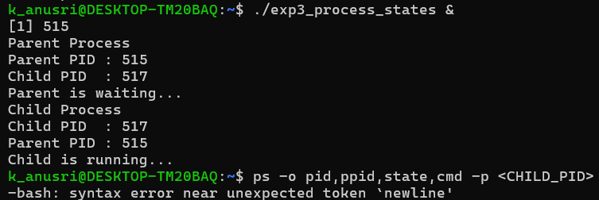
Result
The child process was successfully created using fork(). The PID and PPID of the parent and child processes were displayed, and the process state was observed using the ps command.

